**Ideation Phase**

**Define the Problem Statements**

|  |  |
| --- | --- |
| Date | 19 November 2022 |
| Team ID | PNT2022TMID45883 |
| Project Name | Project – A Novel Method for Handwriting Digit Recognition System |
| Maximum Marks | 2 Marks |

**Customer Problem Statement Template:**

Handwriting recognition is one of the compelling research works going on because every individual in this world has their own style of writing. It is the capability of the computer to identify and understand handwritten digits or characters automatically. Because of the progress in the field of science and technology, everything is being digitalized to reduce human effort. Hence, there comes a need for handwritten digit recognition in many real-time applications. MNIST data set is widely used for this recognition process and it has 70000 handwritten digits. We use Artificial neural networks to train these images and build a deep learning model. Web application is created where the user can upload an image of a handwritten digit. This image is analyzed by the model and the detected result is returned on to UI.

**Example:**

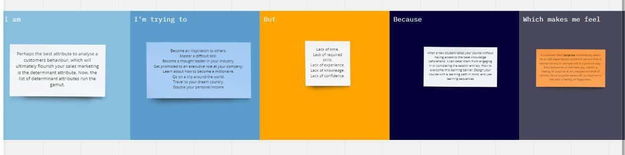

Reference:<https://miro.com/welcomeonboard/dlVxWjZWaUN5eHhEVXh5MkNpMldZV3FKUEZKSnhBNG11bXhZb3g4bGhmNWZMOElVY1dWMDh1d1Y5RkdxZU9MWnwzNDU4NzY0NTM1ODExOTI5MzQxfDI=?share_link_id=13642599616>

|  |  |  |  |  |  |
| --- | --- | --- | --- | --- | --- |
| **Problem Statement (PS)** | **I am (Customer)** | **I’m trying to** | **But** | **Because** | **Which makes me feel** |
| PS-1 | Perhaps the best attribute to analyse a customers behaviour, which will ultimately flourish your sales marketing is the determinant attribute. Now, the list of determinant attributes run the gamut. | Become an inspiration to others.  Master a difficult skill.  Become a thought leader in your industry.  Get promoted to an executive role at your company.  Learn about how to become a millionaire.  Go on a trip around the world. | * Not enough time. * Lack of recognition.   Poor communication skills.   * Lack of managerial involvement. * Lack of growth opportunities. | when a new student takes your course without having access to the base knowledge beforehand, it can deter them from engaging in or completing the session entirely. How to overcome this learning barrier: Design your course with a learning path in mind, and use learning sequences | A customer feels **Surprise** immediately when he or she experiences customer service that is extraordinary or unexpected in a positive way. Even before help  or she feels joy, there's a feeling of surprise at an unexpected level of service. Once surprise wears off, a customer is left with a feeling of Happiness |